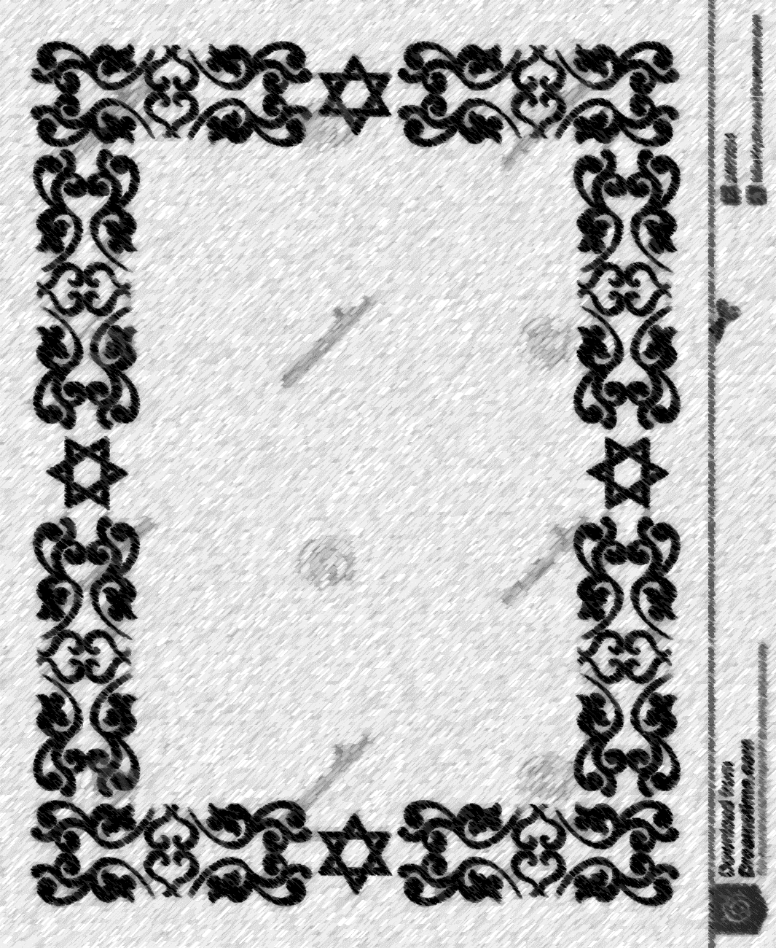

קדש

Certificate of Consecration

This is to certify that

_________­­­­­­­­­_______________________

daughter of

________________________________

born on

___________­­­­­­­­­_____________________

was set apart through the

Covenant of Abraham and Sarah, and given

the Hebrew name of

________________________________

May you do the works of Sarah.

_______________ _______________

_______________ _______________