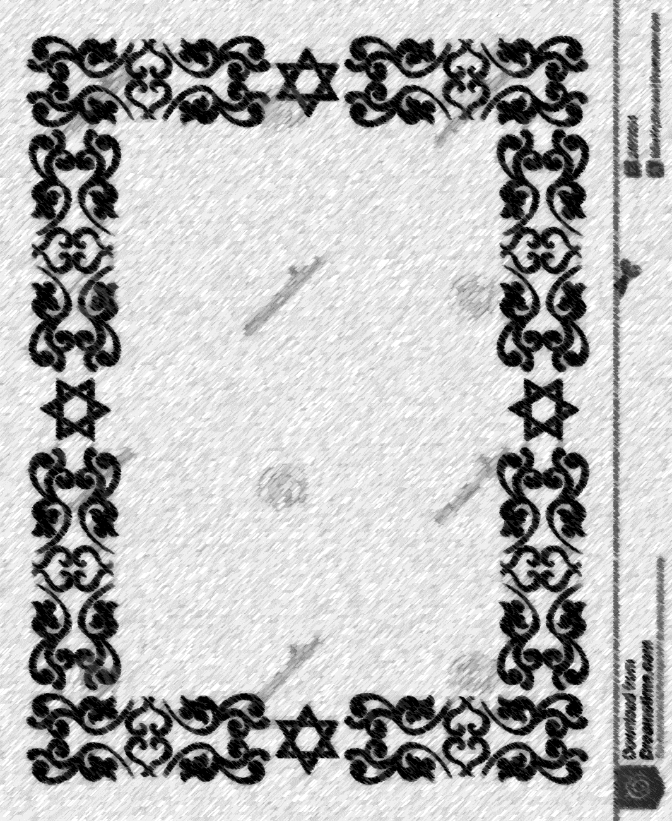

קדש

Certificate of Consecration

This is to certify that

_________­­­­­­­­­_______________________

son of

________________________________

born on

___________­­­­­­­­­_____________________

was set apart through the Covenant

of Abraham and Sarah, received the Covenant Sign and given the Hebrew name of

________________________________

May you do the works of Abraham.

_______________ _______________

_______________ _______________