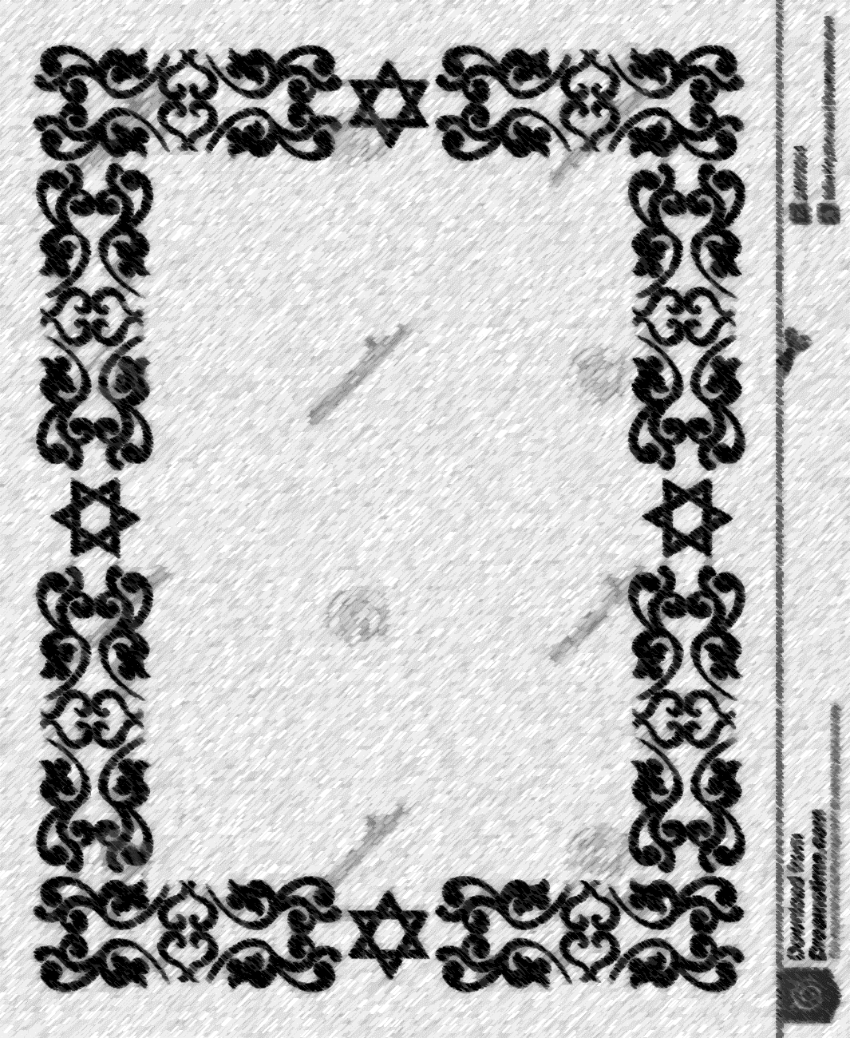

שבועה של הכהונה

Oath of the priesthood

This is to certify that I

_________­­­­­­­­­_______________________

did solemnly swear before God:

to strive to keep myself pure,

to teach my family the Laws of God,

to stand accountable and answerable to

God for the transgressions of my family,

and to administer the Ordinances of

Salvation to them.

_______________ _______________

_______________ _______________